240HW 4

Refer to Tutorial 3: Designing a Page Layout

1. Complete Session 4.3 pages HTML 240 to HTML 259

Add a screenshot of the **pc_info.html** file displayed in a browser after completing Step 5 on page HTML 256. Include the browser address bar. Refer to Figure 3-75 for reference.

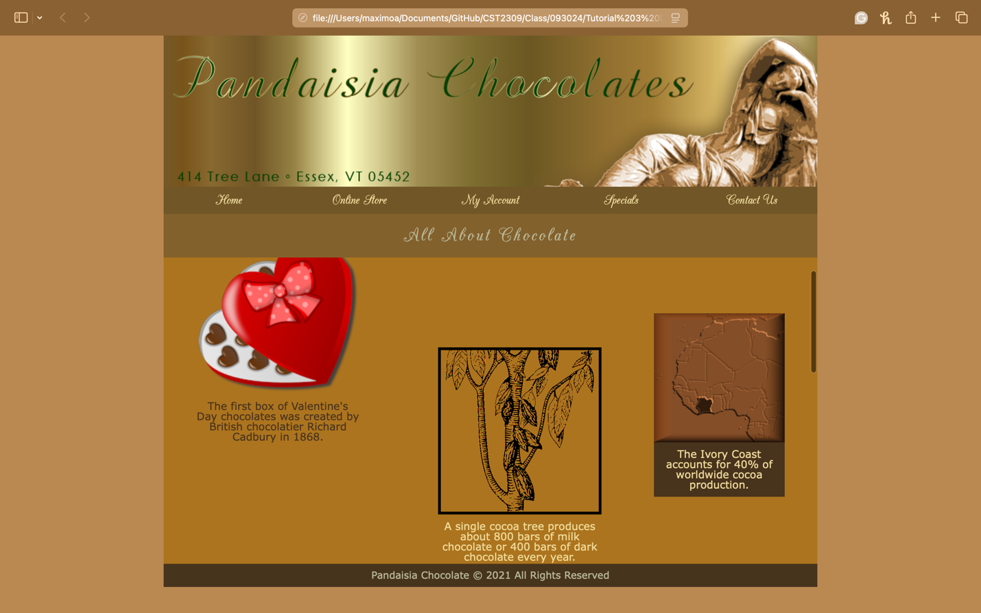

1. Deploy site to Netlify using pc_about as the index.html file| Add URL link in the Comment Section in Blackboard
2. Complete the Session 3.2 Quick Check in Blackboard